Machine Leaning Submission 1

Team: Jan Kruska, Sagar Kalburgi, Pawan, Kashyap Melur Mahesh

Q2)

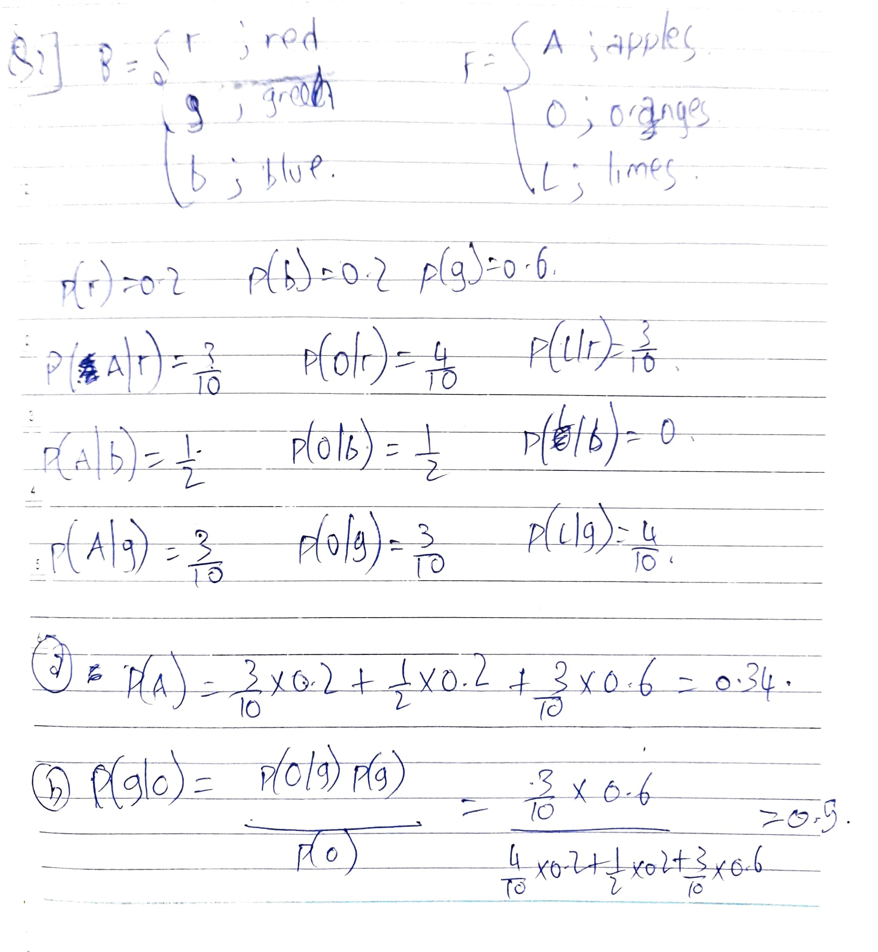

Q5)

a)

pos = np.arange(-5, 5.0, 0.1)

factor = 1 / (np.power(2 * np.pi, 1 / 2) * h)

val = [factor * np.mean(np.exp((-1/(2*h**2)*(samples-i)**2))) for i in pos]

# Compute the number of samples created

return np.stack([pos,val]).transpose()

b)

pos = np.arange(-5, 5.0, 0.1)

n = samples.shape[0]

val = [k/(2*n*(np.linalg.norm(np.sort(np.abs(samples-i))[k-1]))) for i in pos]

# Compute the number of samples created

return np.stack([pos,val]).transpose()

Q6)

a)

return np.sum([np.log(gaussian_mix(x, means, weights, covariances)) for x in X])

def gaussian_mix(x, means, weights, covariances):

return np.sum([weights[k]*gaussian(x,means[k],covariances[:,:,k]) for k in range(len(weights))])

def gaussian(x,mu,sigma):

d = sigma.shape[0]

factor = 1 / np.sqrt((np.power(2 * np.pi, d) * np.linalg.det(sigma)))

return factor * np.exp((-1 / 2 * np.dot((x-mu),np.dot(np.linalg.inv(sigma),(x-mu)))))

b)

n = X.shape[0]

k = len(weights)

gamma = np.empty([n,k])

for i in range(n):

for j in range(k):

gamma[i,j] = (weights[j]*gaussian(X[i,:],means[j],covariances[:,:,j]))/gaussian_mix(X[i,:],means,weights,covariances)

return [getLogLikelihood(means,weights,covariances,X), gamma]

c)

n_k = np.sum(gamma,0)

covariances = np.empty([X.shape[1], X.shape[1], gamma.shape[1]])

means = np.array([np.dot(gamma[:,k],X)/n_k[k] for k in range(gamma.shape[1])])

for k in range(gamma.shape[1]):

# elementwise product of (DxN)(N) => DxN dot-product NxD => DxD

covariances[:, :, k] = np.dot(np.transpose(X - means[k]) * gamma[:, k], X - means[k]) / n_k[k]

# Regularize to avoid numerical anomalies

#covariances[:, :, k] = regularize_cov(covariances[:, :, k], 0.0001)

weights = n_k/X.shape[0]

logLikelihood = getLogLikelihood(means, weights, covariances, X)

return weights, means, covariances, logLikelihood

d)

regularized_cov = covariance + epsilon*np.identity(len(covariance))

return regularized_cov

e)

n_dim = data.shape[1]

weights = np.ones(K) / K

kmeans = KMeans(n_clusters=K,n_init=10).fit(data)

cluster_idx = kmeans.labels_

means = kmeans.cluster_centers_

covariances = np.empty([n_dim,n_dim,K])

for j in range(K):

data_cluster = data[cluster_idx==j]

min_dist = np.inf

for i in range(K):

#compute sum of distances

dist = np.mean(euclidean_distances(data_cluster,[means[j]],squared=True))

if dist < min_dist:

min_dist = dist

covariances[:,:,j] = np.eye(n_dim) * min_dist

for i in range(n_iters):

_, gamma = EStep(means, covariances, weights, data)

weights, means, covariances, _ = MStep(gamma, data)

for k in range(K):

covariances[:,:,k] = regularize_cov(covariances[:,:,k], epsilon)

return [weights, means, covariances]

f)

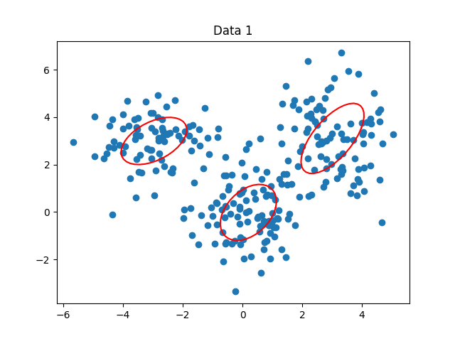

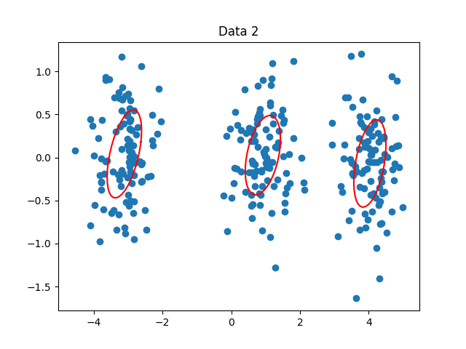

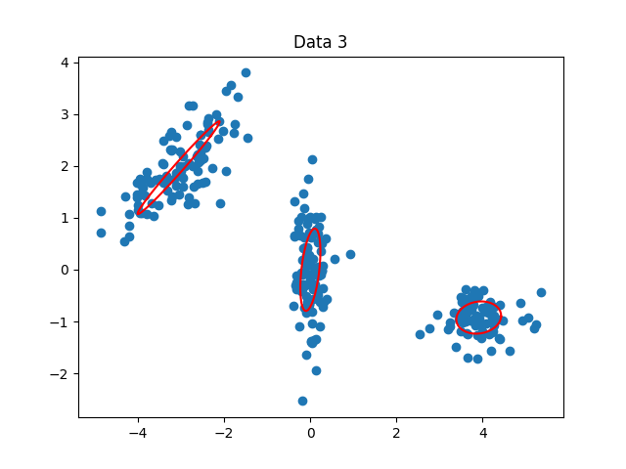

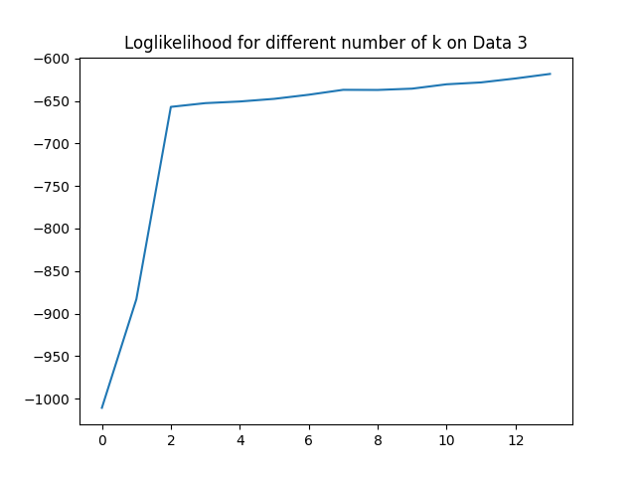

We can clearly see that anything beyond K=2 has no significant improvement. K=2 is optimum.